CAPITAL FACILITIES PLAN

PIERCE COUNTY FIRE PROTECTION DISTRICT NO. 18
(to be adopted as an element of the Pierce County Comprehensive Plan)

INTRODUCTION: The Growth Management Act, at RCW 36.70A.070, requires that the Capital Facilities Plan of each jurisdiction requesting impact fees, be imposed by and through Pierce County, be duly adopted and then included by reference in the Comprehensive Plan, Capital Facilities Element, of the county. This Capital Facilities Plan, which has been duly adopted by Resolution No. of Pierce County Fire Protection District No. 18, fulfills that first step or requirement.

DEFINITIONS: When used in this Capital Facilities Plan, the following words and terms shall have the following meanings:

Concurrency - As used in the Growth Management Act, this term means that adequate services are available at the same time, or concurrent with, a development commencing, so that adverse impacts of such growth or development are thereby mitigated.

Level of Service - See the LEVEL OF SERVICE STANDARDS on the following page.

Turnout Time - means the time beginning when units receive notification of the emergency to the beginning point of response time.

Response Time - means the time immediately following the turnout time that begins when units are en route, (traveling) to the emergency incident and ends when units arrive at the scene.

Total Response Time - The sum of Turnout Time and Response Time together equals a unit's Total Response Time.

Staffed Station - A station that has personnel present with apparatus, prepared to respond 24 hours a day, 7 days a week, 365 days a year. Staff may be paid, volunteer, or a combination of the two.

Unstaffed Station - Any station other than a staffed station as defined above.

LEVEL OF SERVICE STANDARDS (*)

The State Legislature in RCW. 52.33.010 communicates its intent for fire departments to establish Level of Service Standards that permit first responders to arrive in time to prevent "brain death" as it relates to EMS; and to prevent "flash-over" as it relates to fire suppression. The Legislature further acknowledges in RCW. 52.33.020 the following benchmarks in its definitions section relative to these two critical emergency events:

Brain Death: As defined by the American Heart Association, means the irreversible death of brain cells that begins four to six minutes after cardiac arrest.

Flash-Over: As defined by the National Institute of Standards and Technology, means when all combustibles in a room burst into flame and the fire spreads rapidly.

* Flash-Over is dependent on many factors, (fuel load, oxygen supply, size of room, etc.) but is generally recognized as a likely event from 7 minutes to 12 minutes after ignition occurs.

Consistent with the Legislature's intent the following Level of Service Standards are established for Fire Departments within Pierce County, relative to impact mitigation:

TOTAL RESPONSE TIMES (In Minutes) *

Response time includes 1:20 minute Turnout time

Category First Unit Second Unit Balance of First Alarm
URBAN: Typically, an incorporated area or an unincorporated area with a population of over 30,000 and/or a population density of 2,000 people per square mile (or generally within the approved urban growth area):
6:32 11:44 11:44
RURAL 1: An incorporated or unincorporated area with a population between 10,000 and 29,999 and/or a population density of 1,000 to 2,000 people per square mile:
7:50 11:44 14:20
RURAL II: An incorporated or unincorporated area with a population of less than 10,000 or with a population density of less than 1,000 people per square mile:
14:20 19:32 19:32

* To meet these standards, the total response times must be achieved on 90% of the responses within a jurisdiction.
I. Purpose and Background
The purpose of this document is to present an inventory of the current capital facilities of Pierce County Fire District 18 (Fire District) and the anticipated future needs for capital facilities to achieve and maintain the above referenced levels of service for fire protection and Emergency Services. The anticipated future needs are based on projected growth over the twenty-year planning period (through the year 2035), consistent with the Pierce County Comprehensive Plan. This document shall also present methods by which these needs can be addressed.

This plan is also intended to fulfill the Washington Growth Management Act public facility and service requirements of RCW 36.70A.110 and Capital Facilities requirements, which are identified in RCW 36.70A.070 (3) shown below:
"(a) An inventory of existing capital facilities owned by public entities, showing
the locations and capacities of the capital facilities; (b) a forecast of the future
needs for such capital facilities; (c) the proposed locations and capacities of expanded or new capital facilities; (d) at least a six-year plan that will finance such capital facilities within project funding capacities that clearly identifies sources of public money for such purposes; and (e) a requirement to reassess the land use element if probable funding falls short of meeting existing needs and to ensure that the land use element, capital facilities plan element, and financing plan with the capital facilities plan element are coordinated and consistent."

To fulfill this purpose, the document is organized into the following sections:

- Executive Summary
- Fire District 18 Description
- Inventory of Fire District Capital Facilities
- Pierce County Adopted Levels of Service
- Current and Projected Levels of Service
- Projected Growth and Capital Facilities Needs
- Plan for Financing Capital Facility Needs
- Fire District Maps (Appendix A)
- Annual Reports for ______ - _______ (Appendix _)
- Impact Fee Background Information (Appendix _)

II. Executive Summary

Fire District 18 (Orting Valley Fire & Rescue, OVF&R) provides fire protection and emergency medical services for rural and urban areas in central Pierce County. This Capital Facilities Plan, as required by RCW 36.70A.070, provides an overview of the Fire District's existing facilities and equipment together with an estimation of future needs to serve the area within the District's boundaries and those areas to which service is provided on a contractual basis.

The Fire District currently does [not] have the capacity to meet the established Level of Service response standards for either fire or emergency medical service calls within the District.

Based on a review of planned growth within the District boundaries and the City of Orting Urban Growth Areas, this Capital Facilities Plan analyzes the Fire District's capacity to serve projected growth. The results indicate that without Impact Fees the Fire District cannot serve further development within its boundaries without further degradation of the District's capacity to respond effectively to emergency events.

The financing aspect of this Capital Facilities Plan relies on existing property tax revenue, capital reserves and other sources of revenue to pay for facilities and equipment improvements.

The Fire District Commissioners will continue to review the capital facilities needs on an annual basis and budget adequate funds for these purposes. It is anticipated that additional revenue beyond that generated by current property taxes and contractual payments will be necessary to meet a number of major capital facility needs. Such additional revenue may include a combination of increased property taxes, voluntary mitigation fees, SEPA mitigation, impact fees and grants.

III. Fire District I8 Description

The Fire District is nestled in the foothills of Mount Rainier and includes segments of the Puyallup and Carbon Rivers. Its scenic location draws many visitors to enjoy several regional events and the miles of walking and biking trails as well as the rivers. These natural assets present challenges for the district and require a well-trained swift water rescue team as well as preparedness for a potential Lahar (mudflow) or eruption of Mount Rainier.

Utilizing four Fire Stations, the District provides fire protection and emergency medical services to a region of Pierce County of approximately 31 square miles in size. This Primary Response Area (PRA) encompasses Fire District 18 boundaries, including the City of Orting. There is an elementary school, a middle school and a high school as well as the Washington State Soldiers Home and Colony. The PRA includes low to medium density residential housing, moderate intensity commercial properties, a heavy industrial park and a variety of agricultural and rural lands. Much of the Fire District PRA is rural. The 2010 population of this service area was approximately 13,250. The boundaries of the Fire District and of the Alderton-McMillin Community Plan substantially overlap each other but they do not coincide. Additionally the Fire District now includes the City of Orting while the Alderton-Micmillin Community Plan does not.

The Fire District was originally formed as a volunteer service and is now a combination department of 15 career and a cadre of volunteer fire fighters. The District is governed by five Fire Commissioners elected by the voters of the District. The management team includes the full-time Fire Chief, a full time District Secretary and a part time Volunteer Receptionist.

The Fire district staff maintains a culture of providing the best services possible, as well as being a visible partner in the community. It enjoys widespread community support.

IV. Inventory of Fire District Capital Facilities

The District owns and maintains four fire stations: one in the City of Orting; one along the Orting-Kapowsin Highway; one along State Route 162; and one on Patterson Rd. Information regarding these stations is found in Table 1. Photographs and brief descriptions appear below.

TABLE 1: FIRE DISTRICT 18 STATION INVENTORY
Station | Location | Square Footage | Number of Bays | Site  Acreage
Orting Station 40 | 401 Washington Ave SE | 8713 | 3 | N/A
Orting Station 41 | 11 206 State Route 162 | 2752 | 2 | 2.02
Orting Station 42 | 19210 Patterson Road | 1600 | 2 | 1.0
Orting Station 43 | 14919 Orting-Kapowsin HWY E | 2400 | 2 | .91
Total 4 4 |  | 15,465 | 9 | 3.93

OVF&R Station 40 Headquarters
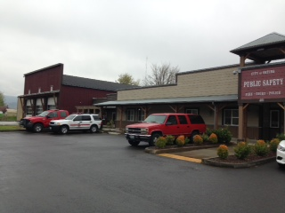
401 Washington Ave, Orting
Built in 2007, this 12,800 square foot facility consists of three double-deep back-in apparatus bays. This station serves the area in and around the City of Orting. This is a fully staffed station. The building is shared with the City of Orting and The Orting Police.

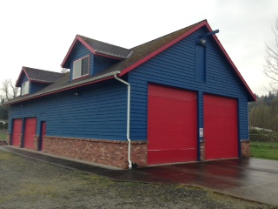

OVF&R Station 41 (McMillan Station)
11206 State Route 162 E
Built in 1995 this 2,752 square foot facility consists of two back-in apparatus bays. This station functions as the volunteer residence station.

OVF&R Station 42 (Patterson Station)
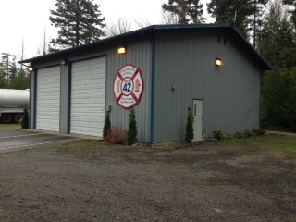
19210 Patterson Road
Built in 1992, this 1,600 square foot facility consists of two apparatus bays. This station primarily serves the eastern section of the Fire District. This is an unstaffed volunteer station.

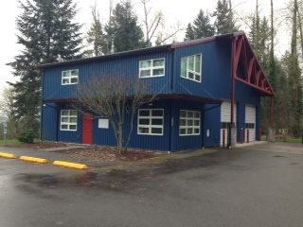
OVF&R Station 43(Cemetery Hill Station)
14919 Orting-Kapowsin HWY E
Built in 1999, this 2,400 square foot facility consists of two apparatus bays. This station generally serves the southern section of the Fire District. This a part-time staffed station.

PCFD #18 Station 40 Apparatus Inventory

Number Year Make Unit
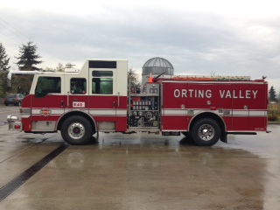

E-40 2007 Pierce Pumper

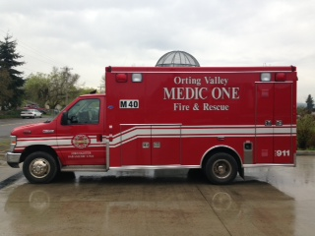

E43-402 2008 Ford Ambulance

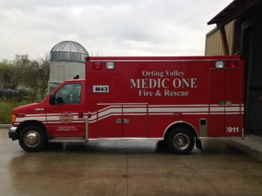
M43-402 2006 Ford Ambulance

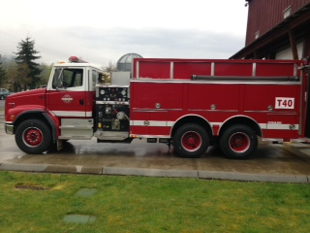

T-40 1999 Freightliner Tender

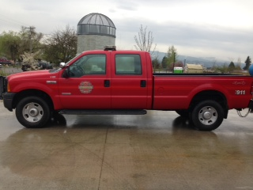
U-402 2006 Ford Pick Up

C-40 2008 Ford Expedition

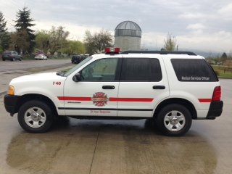
MSO-40 2005 Ford Explorer

PCFD #18 Station 40 Apparatus Continued

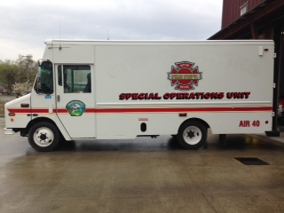

Air-40 2001 Grumman SOU

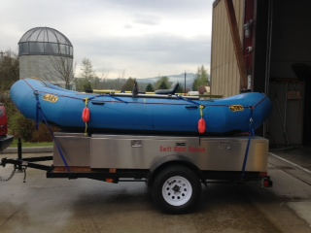

Boat Trailer 2011 Bulldog/ Swiftwater Rescue Boat

PCFD #18 Station 41 Inventory

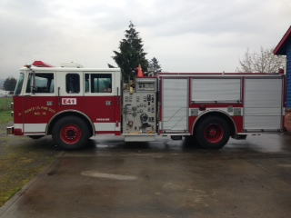
E-41 1996 Pierce Pumper

PCFD #18 Station 42 Apparatus Inventory

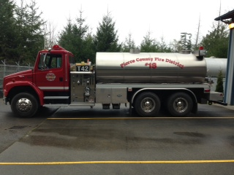

T-42 2003 Freightliner Tender

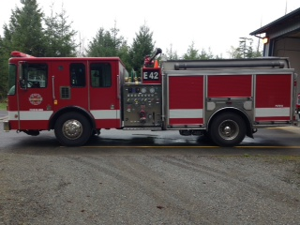

E-42 2003 HME Fire Engine

PCFD #18 Station 43 Apparatus Inventory

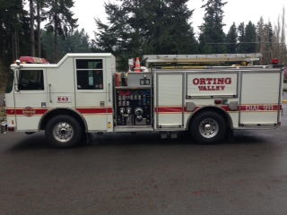

E-43 2003 Pierce Pumper

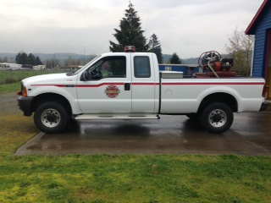

43-PU 2001 Ford F250

V. Current and Projected Levels of Fire Service

All of the PRA is accessible by Fire District apparatus within 6 to 14 minutes from the nearest Fire District 18 Station. Fire District 18 measures response time from the first time it is notified of an emergency event to the time the first apparatus arrives at the scene.

The basic practice of the Fire District is to respond safely and as quickly as possible to all emergency calls within the PRA. Current fire and emergency response times do [not] meet the level of service standards established by the Pierce County Comprehensive Plan.

In addition, the level of fire and emergency medical service currently being provided by the Fire District does [not] meet the expectations of community residents. Nonetheless, participants at public meetings and during the development of the 2011 Strategic Plan continued to praise the service received.

Within this document's 20-year planning horizon, the Fire District intends to meet and maintain the Pierce County Comprehensive Plan Level of Service standards for fire and medical protection.

Significant development within the PRA, whether residential, commercial or industrial, will move the District into a deficiency mode of operation unless appropriate capital facility improvements are provided. This plan identifies the addition of new and improved capital facilities required to serve the projected growth and meet the levels of service as established in the Pierce County Comprehensive Plan.

VI. Projected Growth and Capital Facility Needs
(2015-2035)

The Pierce County 20-year Capital Facilities Plan indicated the Fire District PRS population was 13,114 in 2010, and provided a forecast of 20,237 for 2022. This was based on average growth seen in the City of Orting and in the fire district surrounding Orting from the year 2000 to 2010. It does not consider governmental growth limitations imposed because of flood zones, LAHAR considerations, etc. (See Appendix _, Pierce County Growth estimates by Special District)

Projected population figures for the PRA are summarized in Table _.

Fire District 18 recognizes that the Growth Management Act requires an update to the Pierce County Comprehensive Plan, including 20 year growth projections. The District will coordinate with Pierce County to update this Capital Facilities Plan for consistency with new projections, and when the need for additional services for community populations arises.

The Pierce County 20-Year Capital Facilities Plan also provided 2035 projections for household and employment growth within the Fire District.

An analysis of the workload data (total number of annual incidents) for the years 2010 and 2012, indicates an increase from 1,368 incidents to 1,524, or an 11.4% increase which reflects an average annual increase of 3.8%. Based on the above stated population growth between 2015 and 2035, the District incident total will reach approximately 2,798 by 2035, based on an annual 3.8% increase between 2015 and 2035.

In order to meet the Level of Service standards set forth in the Pierce County Comprehensive Plan, the replacement and purchase of additional fire and emergency apparatus will be required. Tables 4 and 5 provide the information and rationale to add fire and emergency apparatus through the 2015-2035 planning horizons to meet projected growth figures within the Fire District PRA boundaries.

Fire District Commissioners evaluated several action options to address the potential impacts of growth including: ???

Table 6 contains the major components of the Action Plan developed by the Fire Commission for implementation within the 20-year planning period to respond to projected growth in the PRA.

VII. Plan for Financing Capital Facility Needs

Overview

This capital facilities plan projects that the District will invest over $10 million in capital facilities over the current 10-year planning period (through the year 2025). For purposes of this Plan, capital facility investments are placed in two categories:

- Type 1 - Capital facilities that would be needed to serve existing residential, commercial, industrial and other land uses regardless of whether new development occurred or not (i.e. replacement of existing apparatus). Investment of approximately $3.5 million will be needed for capital facilities that fall within this category.

- Type 2 - Capital facilities needed primarily to serve new growth and development. These facilities would likely not be needed if there were no new development. However, once constructed, they will also benefit existing development. In order to continue to meet the Pierce County Comprehensive Plan's Level of Service standard, it is anticipated that the District will invest approximately $6.5 million from 2015-2025 for capital facilities that are primarily needed because of planned growth and development.

Sources of Revenue

For new capital facilities all funding sources allowed by law to fire districts will be considered, including, but not limited to:

- Annual revenues (property taxes for fire and medical functions)
- Reserves
- Fire mitigation fees
- Excess levies
- Grants
- Capital facility bonds
- Fire benefit charges
- Local improvement districts

Annual Revenues - Annual revenues are derived from property taxes and other income sources such as contracts for service and basic life support (BLS) transport reimbursement.

Property taxes are a major source of revenue for the District. Fire Districts generally have a maximum tax rate of $1.50 per $1,000 of assessed value. The District's property tax levy rate has fluctuated between $_____ and $______ per $1,000 of assessed value from_____ to______. Property Valuations, Levy Rate and actual tax revenue information is found in Table __.

Washington State law limits the increase in property taxes by individual taxing districts to 1 % per year, plus tax revenue generated by new construction (RCW 84.55). Voter approval is required to exceed the 1 % annual increase (this does not include taxes from new construction).

Reserves - The accumulated surpluses from previous years make up District reserves.

Fire Mitigation Fees - Fire mitigation fees include voluntary agreements, SEPA mitigation and/or fire impact fees, and/or subdivision regulations/provisions.

The Fire District may request mitigation fees pursuant to RCW 82.02.020 (voluntary agreements) and/or RCW43.21C.060 (SEPA mitigation) from developers to partially finance planned capital facilities needed to serve new growth. However, these mechanisms would not capture the incremental impacts to Fire/EMS services that smaller developments might cause over time. For example, they would not apply to construction of a new single-family residence on an existing lot.

Pierce County and the City of Orting currently do not have fire impact fee ordinances that would allow collection of impact fees for both larger and smaller developments pursuant to RCW 82.02.050 - .100. The Fire District encourages the County and City to adopt fire impact fee ordinances and this Capital Facilities Plan assumes that fire impact fee collection will commence in 2017. If the County and/or City do not adopt impact fees by 2017, then the District will be required to take additional action to ensure the continued financial feasibility of the Capital Facilities Plan.

Excess Levies – Excess levies are voter approved property taxes allowed by the Washington State Constitution and statutes in addition to the three fifty-cent as valorem tax levies authorized by RCW 52.16.130, RCW 52.16.140 and RCW 52.16.160.

Grants - Grants are dependent on availability of federal and state funding sources, such as funding from the Federal Emergency Management Agency. Because of the uncertainty associated with grant applications, only a small portion of the financing plan specifies grants as a source of funding.

Capital Facilities Bonds – Capital facility bonds are allowed for fire protection districts by RCW 52.16.80 for the purchase of capital facilities, provided that the district indebtedness does not exceed ¾ of 1% of the taxable value of all property within the district.

Fire Benefit Charges – Fire benefit charges are authorized by RCW 52.18 for fire districts, with voter approval. It is a charge reasonably proportioned to the benefit received by a residential or commercial property from the provision of fire service.

Local Improvement Districts– Local Improvement Districts are authorized by RCW 52.20 to finance capital improvements, and may or may not involve the sale of bonds, but usually do include annual assessments payable by benefited property owners within the district.

Projection of Future Revenue

From 20 to 20 , total District revenues increased (decreased?) by approximately ____% per year. The District is projecting that operating expenses will increase by ____% per year. This is higher than experienced over the last five years. However, the District is expecting greater operating expenses due to factors such as EMS costs associated with the aging population and rising fuel prices. Finally, it is anticipated that any residual dollars not spent will be available for capital facility expenditures.

The total revenues, operating expenses and funds available for capital improvements are shown below in the Table 8. The total revenue column assumes that collection of impact fees will commence in 2017(?).

Projection of Capital Facility Costs

Capital facility projects, costs and funding sources for the 20-year planning period through 2033 are shown below.

It should be noted that any new Station and associated fire engine estimates in 2032-2033 are divided between Type 1 and Type 2 costs. This is because the new station will be needed to serve both existing development and new development (as it will be sized to serve growth). Therefore, the cost of this station and its new apparatus were apportioned among existing development and new growth.

Cash Flow Projections

Cash flow projections include beginning cash and reserves, annual revenues, operating expenses, capital expenses, and ending balances. Table ___ presents this information.

Financial Feasibility of Capital Facilities Plan

The District acknowledges the need for this Capital Facility Plan to be financially feasible in order to serve current population and forecasted growth, but also recognizes uncertainties associated with making future growth and financial projections. Additionally, the District does not control whether impact fees will be adopted by Pierce County or the City of Orting. In the event that impact fees are not adopted or probable funding is otherwise inadequate to finance the needed capital facilities, the Fire District can employ the following strategies to ensure that the Capital Facilities Plan is financially feasible:

- Work with the County to make adjustments to level of service;
- Make adjustments to the planned capital facility expenditures;
- Make adjustments to sources of revenue; or
- A combination of the options above.

The intention of these adjustments would be to achieve a balance between available revenue and capital facility expenditures.

APPENDIX A - Fire District Maps

APPENDIX B - Annual Reports for 20__-20__

APPENDIX C - Tables

Table ___ - Fire protection capital facilities projected to new development needs with associated costs, 2015 to 2035
Capital Facility | Estimated cost
Construction of station #41 | $ 2,000,000
Construction of Training facility at #41 | $ 500,000
Addition of Apparatus bays and living/office areas at #42 and #43 | $ 1,000,000
Purchase of property | $ 400,000
Purchase/Construct new headquarters | $ 5,000,000
Architectural/Engineering Costs | $ 890,000
Total | $ 9,790,000

Table ___ – Estimated cost of fire protection capital borne by the fire district and new development, 2015 to 2035
Category | Amount
Total estimated cost of capital facilities | $ 9,790,000
Percentage of estimated cost invested by the fire district | 35%
Amount of estimated investment by the fire district | $ 3,426,500
Percentage of estimated cost invested by new investment | 65%
Amount of estimated investment by new development | $ 6,363,500

Table ___ – Estimated cost of fire protection capital borne by residential construction,
2015 to 2035
Category | Amount
Amount of estimated investment by new development | $ 6,363,500
Percentage of new development estimated investment | 60%
Amount of estimated investment borne by residential | $ 3,818,100
Projected number of new dwelling units constructed (population incr. divided by 2.5) | 2849
Estimated amount of investment borne per dwelling unit | $ 1,340

Table ___ – Estimated cost of fire protection capital borne by commercial and industrial construction, 2015 to 2035
Category | Amount
Amount of estimated investment by new development | $ 6,363,500
Percentage of new development investment | 40%
Amount of estimated investment borne by Commercial/Industrial | $ 2,545,400
Projected square footage of new commercial/industrial | 300,000
Estimated amount of investment borne per square foot of | $ 8.48

Table ___ – Fire district commercial/industrial and impact fee rates and projected revenues,
2015 through 2035
Category | Amount
Projected number of new dwelling units constructed | 2849
Projected square footage of new commercial/industrial | 300,000
Impact fee per residential dwelling construction | $1,340
Impact fee per square foot of commercial/industrial construction | $8.48
Percentage of impact fees from residential | 60%
Percentage of impact fees from commercial/industrial | 40%
Projected revenue from residential construction | $ 3,818,100
Projected revenue from commercial/industrial construction | $ 2,545,400
Total projected impact fee revenue from all sources | $ 6,363,500
Projected annual revenue for residential impact fees | $ 190,905
Projected annual revenue for commercial/industrial impact fees | $ 127,270
Total annual projected impact fee revenue from all | $ 318,175

PLEASE NOTE:

The following text is JUST A PLACE HOLDER {copied from Watcom County}, or as additional sample information, until anticipated data can be determined

Determination of Impact Fees

Revenue and cash flow projections in Chapter VIII include impact fees that the Fire District is planning to collect beginning in January 2017(?) and continuing throughout the planning period. These funds will supplement other sources of revenue available for Capital Facilities. The background for determining those impact fees appears below.

Table 12 contains the major Capital projects identified in the Capital Facilities Plan and the attendant estimated costs to serve the projected growth and development through the end of 2033.

TABLE 12: FIRE PROTECTION CAPITAL FACILITIES PROJECTED TO NEW DEVELOPMENT NEEDS WITH ASSOCIATED COSTS, 2017 TO 2036
Capital Facilities | Estimated
Construction of New Columbia Valley Satellite Fire Station | $945,000
Addition of Sleeping Quarter to Kendall Fire Station | $380,475
Architectural and Engineering Costs for New Sumas Fire | $78,660
New Fire Engine for Columbia Valley Satellite Station | $450,000
New Ambulance (Aid Car) for Columbia Valley Satellite | $125,000
New Utility/Command Vehicle for Columbia Valley Satellite | $45,000
Construction of New Sumas Fire Station | $486,400
New Fire Engine for Sumas Fire Station | $144,000
New Utility/Command Vehicle for Sumas Station | $45,000
TOTAL | $2,699,535

One element of this planning process involved responding to the need to estimate how much of the cost of the new Capital Facilities should be borne by new development and what amount should be the responsibility of the Fire District. State Law does not allow new development to pay 100% of the costs because current residents and commercial and industrial firms also benefit from these new and improved facilities.

The information about the amount of investment made in the new and improved Capital Facilities by the Fire District and by the new development is found below in Table 13.

TABLE 13: ESTIMATED COST OF FIRE PROTECTION CAPITAL BORNE BY THE FIRE DISTRICT AND NEW DEVELOPMENT, 2O17 TO ???
Category |  |  | Amount
Total | Estimated Cost of Capital Facilities for New |  | $2,699,535
Percentage of Estimated Cost Invested by the Fire |  | 35%
Amount of Estimated Investment by the Fire District |  | $944,837
Percentage of Estimated Cost Invested by New |  | 65%
Amount of Estimated Investment by New Development |  | $1,754,698

Another element of planning involved estimating how the new individual dwelling units and the construction of new commercial and industrial spaces would share in the cost of the Capital Facilities needed to serve the projected growth and development.

The key figures related to the determination of the Residential Construction Impact Fee appear below in Table 14.

TABLE 14: ESTIMATED COST OF FIRE PROTECTION CAPITAL BORNE BY RESIDENTIAL CONSTRUCTION, 2017 TO 2036
Category | Amount
Amount of Estimated Investment by New Development | $1,754,698
Percentage of New Development Estimated Investment by | 60%
Amount of Estimated Investment Borne by Residential | $1,052,819
Projected Number of New Dwelling Units Constructed!" | 1,083
Estimated Amount of Investment Borne per Dwelling Unit | $972.26

Table 15 provides the key figures used to determine the Commercial/Industrial Construction Impact Fee.

TABLE 15: ESTIMATED COST OF FIRE PROTECTION CAPITAL BORNE BY COMMERCIAL AND INDUSTRIAL CONSTRUCTION, 2017
< Category | Amount
Amount of Estimated Investment by New Development | $1,754,698
Percentage of New Development Investment by | 40%
Amount of Estimated Investment Borne by | $701,879
Projected Square Footage of New Commercial/Industrial | 807,248
Estimated Amount of Investment Borne per Sq, Ft. of | $0.87

This figure of 7,083 was extrapolated by Whatcom County Planning and Development Services Staff.

Making use of the Impact Fees for the construction of dwelling units and commercial/industrial space, it is possible to project the potential revenues from each. Some of these figures were used to create the revenue projections in Table 8 and cash flow projections in Table 10 in Chapter VIM.
Impact Fee Rates and related projected revenues from these rates are located in Table 16.

TABLE 16: FIRE DISTRICT COMMERCIAL/INDUSTRIAL AND IMPACT FEE RATES AND PROJECTED REVENUES, 2017 THROUGH 2036
Category | Amount
Projected Number of New Dwelling Units Constructed!" | 1,083
Projected Square Footage of Commercial/Industrial Construction | 807,248
Impact Fee per Residential Dwelling Construction | $972.26
Impact Fee per Square Foot of Commercial/Industrial Construction | $0.87
Percentage of Impact Fees from Residential | 60%
Percentage of Impact Fees from Commercial/Industrial | 40%
Projected Revenue from Residential Construction | $1,052,819
Projected Revenue from Commercial/Industrial Construction | $701,879
Total Projected Impact Fee Revenue from All Sources | $1,754,698
Projected Annual Revenue for Residential Impact Fees | $52,641
Projected Annual Revenue for Commercial/Industrial Impact Fees | $35,064
Total Annual Projected Impact Fee Revenue from All | $87,735

